Project 1 (CCNA)
Cisco Packet Tracer Network Documentation

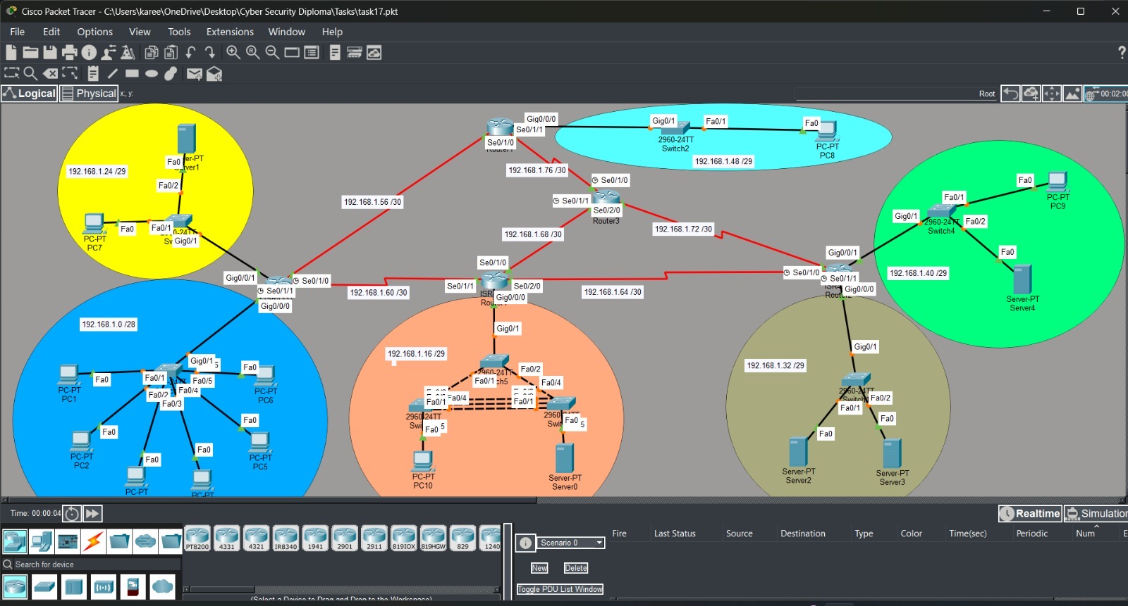
Figure 1. Complete Network Topology

Student Name: Kareem Hamdy Mohamed Hamd
Supervisor Name: Saher Waleed
Base Network: 192.168.1.0/24

1. Network Topology
Figure 2. Network topology implemented in Cisco Packet Tracer.
Methodology: The topology was designed using five routers, multiple Layer 2 switches, end devices, and serial point-to-point links. The LANs were separated into different subnets, while the routers were interconnected using /30 serial networks. OSPF was used as the dynamic routing protocol to provide connectivity between the different network segments.

2. Subnetting
The original address space is 192.168.1.0/24. Variable Length Subnet Masking (VLSM) was used to divide the /24 network according to the required number of hosts and point-to-point links.
Network | Network ID | Mask | Usable Hosts | Usable Range | Broadcast
Blue LAN | 192.168.1.0/28 | 255.255.255.240 | 14 | 192.168.1.1–192.168.1.14 | 192.168.1.15
Orange LAN | 192.168.1.16/29 | 255.255.255.248 | 6 | 192.168.1.17–192.168.1.22 | 192.168.1.23
Yellow LAN | 192.168.1.24/29 | 255.255.255.248 | 6 | 192.168.1.25–192.168.1.30 | 192.168.1.31
Brown LAN | 192.168.1.32/29 | 255.255.255.248 | 6 | 192.168.1.33–192.168.1.38 | 192.168.1.39
Green LAN | 192.168.1.40/29 | 255.255.255.248 | 6 | 192.168.1.41–192.168.1.46 | 192.168.1.47
Light Blue LAN | 192.168.1.48/29 | 255.255.255.248 | 6 | 192.168.1.49–192.168.1.54 | 192.168.1.55
R0–R1 | 192.168.1.56/30 | 255.255.255.252 | 2 | 192.168.1.57–192.168.1.58 | 192.168.1.59
R0–R4 | 192.168.1.60/30 | 255.255.255.252 | 2 | 192.168.1.61–192.168.1.62 | 192.168.1.63
R4–R2 | 192.168.1.64/30 | 255.255.255.252 | 2 | 192.168.1.65–192.168.1.66 | 192.168.1.67
R3–R4 | 192.168.1.68/30 | 255.255.255.252 | 2 | 192.168.1.69–192.168.1.70 | 192.168.1.71
R3–R2 | 192.168.1.72/30 | 255.255.255.252 | 2 | 192.168.1.73–192.168.1.74 | 192.168.1.75
R1–R3 | 192.168.1.76/30 | 255.255.255.252 | 2 | 192.168.1.77–192.168.1.78 | 192.168.1.79
Methodology: VLSM was selected so that larger LANs receive larger subnets while point-to-point serial links use /30 networks, minimizing address waste. Each subnet has a unique Network ID and broadcast address.

3. IP Addressing Table
Device | Interface | IP Address | Subnet Mask
Router0 | G0/0/0 | 192.168.1.1 | 255.255.255.240
Switch0 | VLAN/Management | 192.168.1.2 | 255.255.255.240
PC1 | NIC | 192.168.1.3 | 255.255.255.240
PC2 | NIC | 192.168.1.4 | 255.255.255.240
PC3 | NIC | 192.168.1.5 | 255.255.255.240
PC4 | NIC | 192.168.1.6 | 255.255.255.240
PC5 | NIC | 192.168.1.7 | 255.255.255.240
PC6 | NIC | 192.168.1.8 | 255.255.255.240
Router0 | G0/0/1 | 192.168.1.25 | 255.255.255.248
Switch3 | VLAN/Management | 192.168.1.26 | 255.255.255.248
PC7 | NIC | 192.168.1.27 | 255.255.255.248
Server1 | NIC | 192.168.1.28 | 255.255.255.248
Router1 | G0/0/0 | 192.168.1.49 | 255.255.255.248
Switch2 | VLAN/Management | 192.168.1.50 | 255.255.255.248
PC8 | NIC | 192.168.1.51 | 255.255.255.248
Router2 | G0/0/0 | 192.168.1.33 | 255.255.255.248
Switch1 | VLAN/Management | 192.168.1.34 | 255.255.255.248
Server2 | NIC | 192.168.1.35 | 255.255.255.248
Server3 | NIC | 192.168.1.36 | 255.255.255.248
Router2 | G0/0/1 | 192.168.1.41 | 255.255.255.248
Switch4 | VLAN/Management | 192.168.1.42 | 255.255.255.248
Server4 | NIC | 192.168.1.43 | 255.255.255.248
PC9 | NIC | 192.168.1.44 | 255.255.255.248
Router4 | G0/0/0 | 192.168.1.17 | 255.255.255.248
Switch5 | VLAN/Management | 192.168.1.18 | 255.255.255.248
Switch6 | VLAN/Management | 192.168.1.19 | 255.255.255.248
Switch7 | VLAN/Management | 192.168.1.20 | 255.255.255.248
PC10 | NIC | 192.168.1.21 | 255.255.255.248
Server0 | NIC | 192.168.1.22 | 255.255.255.248
Serial interfaces:
Device | Interface | IP Address | Prefix
Router0 | S0/1/0 | 192.168.1.58 | /30
Router0 | S0/1/1 | 192.168.1.62 | /30
Router1 | S0/1/0 | 192.168.1.57 | /30
Router1 | S0/1/1 | 192.168.1.77 | /30
Router2 | S0/1/0 | 192.168.1.74 | /30
Router2 | S0/1/1 | 192.168.1.65 | /30
Router3 | S0/1/0 | 192.168.1.78 | /30
Router3 | S0/1/1 | 192.168.1.69 | /30
Router3 | S0/2/0 | 192.168.1.73 | /30
Router4 | S0/1/0 | 192.168.1.70 | /30
Router4 | S0/1/1 | 192.168.1.61 | /30
Router4 | S0/2/0 | 192.168.1.66 | /30

4. Router Interface Configuration

Router0
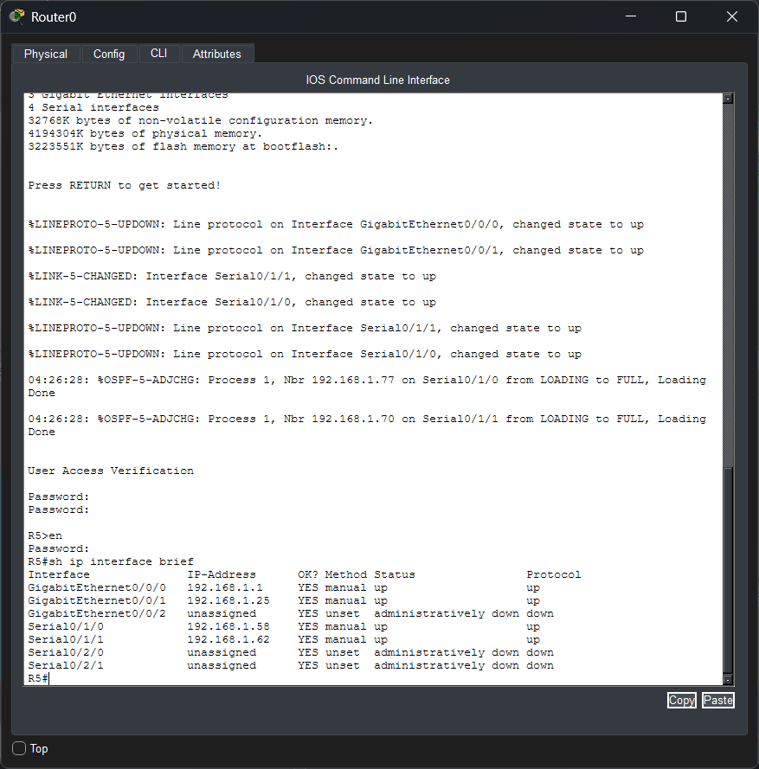
Figure. Router0 interface verification using show ip interface brief.
Methodology: Router0 provides gateway connectivity for the Blue and Yellow LANs and connects to two serial point-to-point networks. The interface status was verified using the show ip interface brief command. Active interfaces show both Status and Protocol as up.

Router1
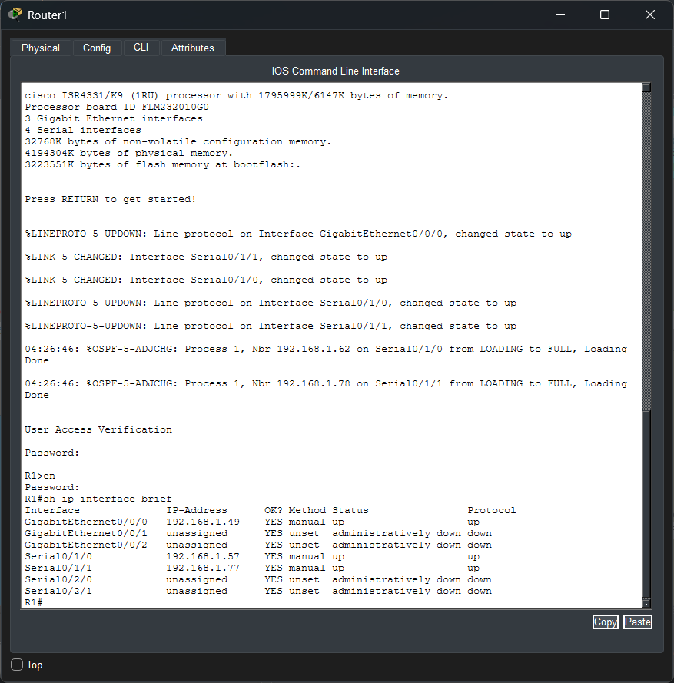
Figure. Router1 interface verification using show ip interface brief.
Methodology: Router1 provides gateway connectivity for the Light Blue LAN and connects to two serial point-to-point networks. The interface status was verified using the show ip interface brief command. Active interfaces show both Status and Protocol as up.

Router2
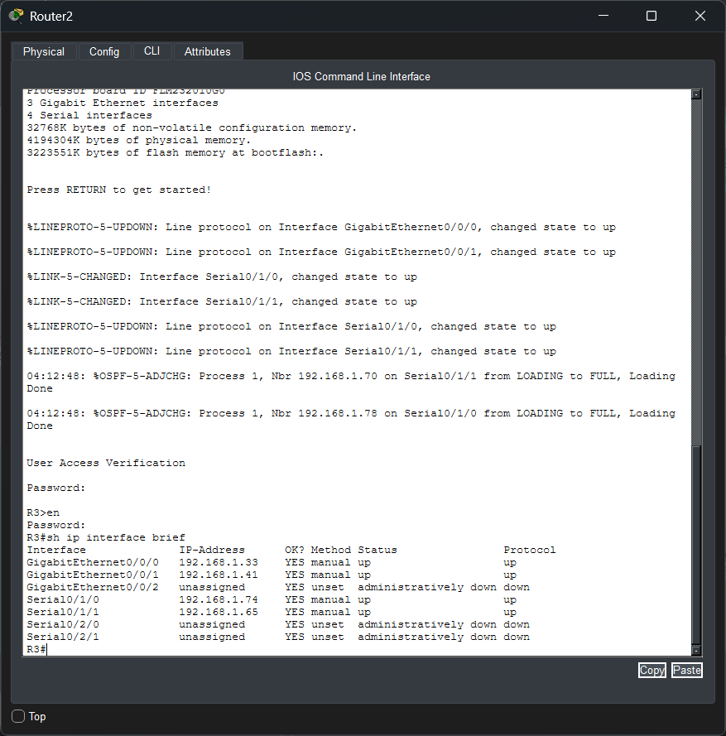
Figure. Router2 interface verification using show ip interface brief.
Methodology: Router2 provides gateway connectivity for the Brown and Green LANs and connects to two serial point-to-point networks. The interface status was verified using the show ip interface brief command. Active interfaces show both Status and Protocol as up.

Router3
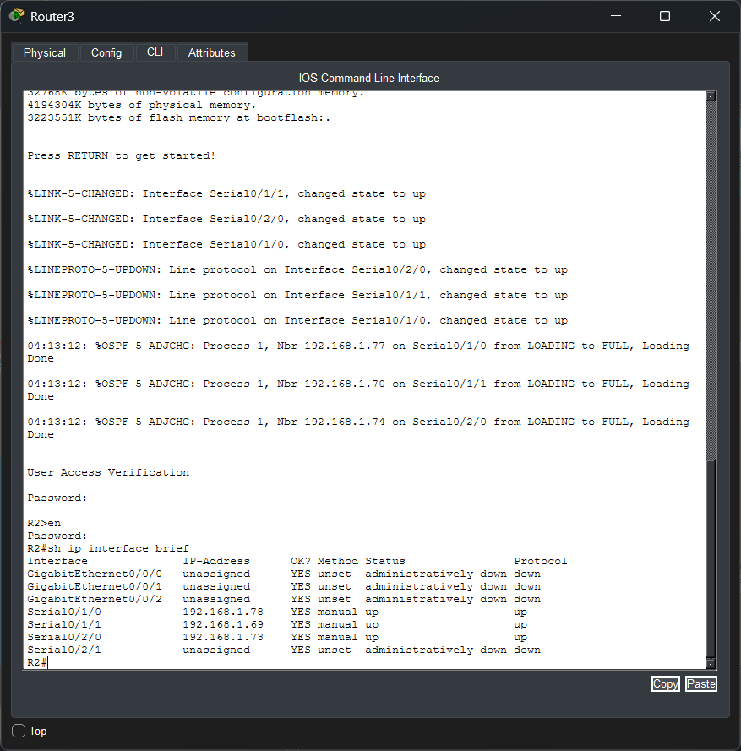
Figure. Router3 interface verification using show ip interface brief.
Methodology: Router3 operates as a transit router with three serial interfaces connecting different parts of the routed topology. The interface status was verified using the show ip interface brief command. Active interfaces show both Status and Protocol as up.

Router4
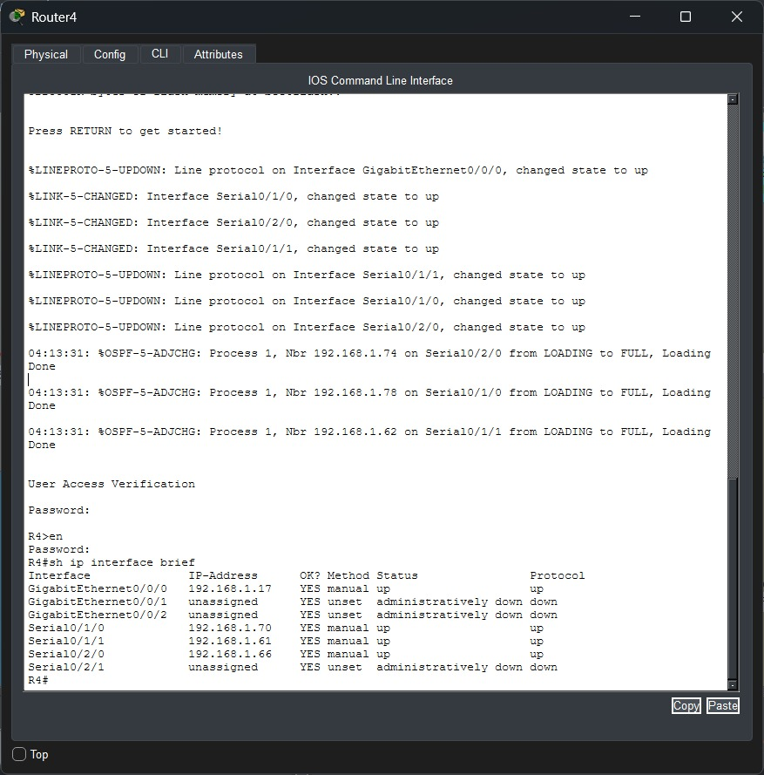
Figure. Router4 interface verification using show ip interface brief.
Methodology: Router4 provides gateway connectivity for the Orange LAN and connects to three serial point-to-point networks. The interface status was verified using the show ip interface brief command. Active interfaces show both Status and Protocol as up.

5. SSH Configuration

5.1 SSH on Router0
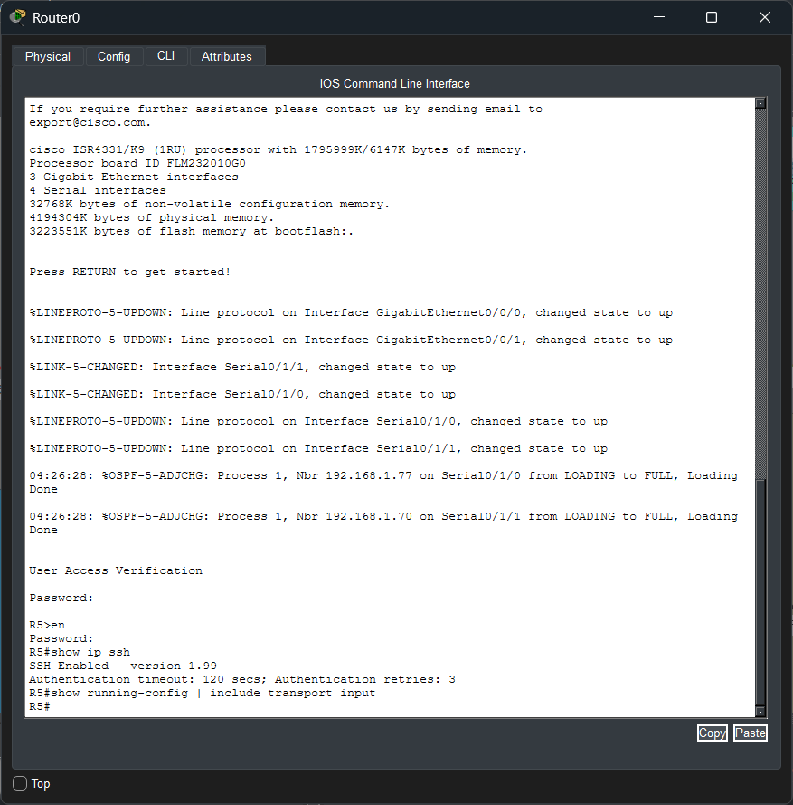
Figure. SSH verification on Router0.
Methodology: SSH was enabled on Router0 to provide secure remote management. The show ip ssh command confirms that SSH is enabled. The VTY configuration uses local authentication with login local.

5.2 SSH on Switch0
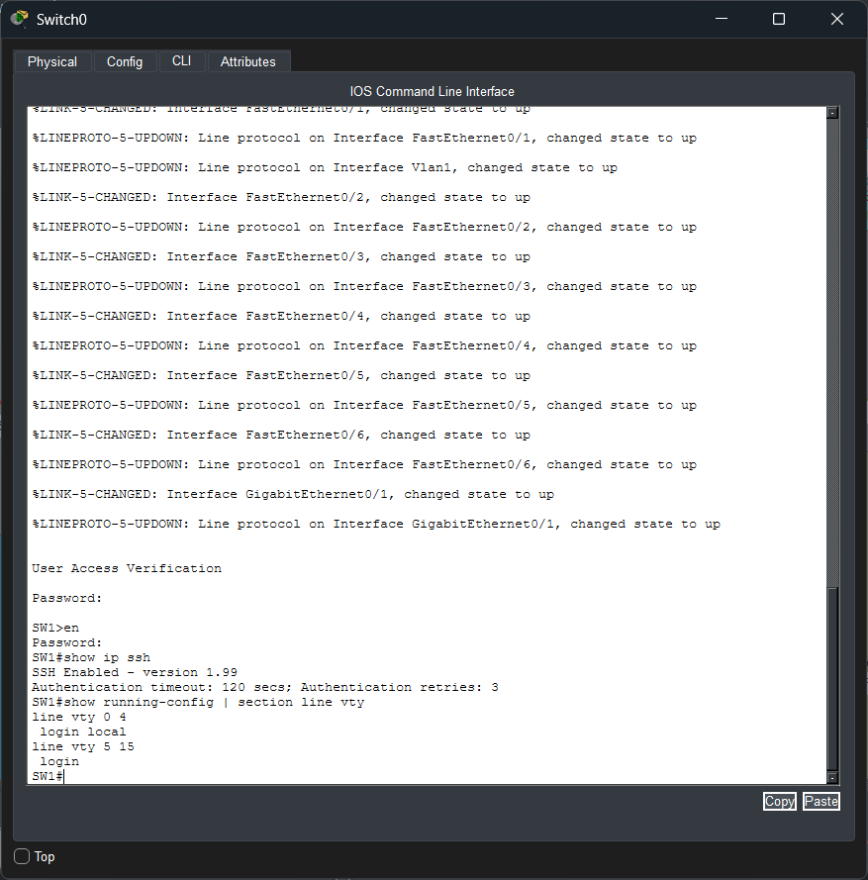
Figure. SSH verification on Switch0.
Methodology: SSH was enabled on Switch0 for secure remote administration. The output confirms SSH version 1.99 is enabled and shows the VTY authentication configuration.

6. EtherChannel Configuration
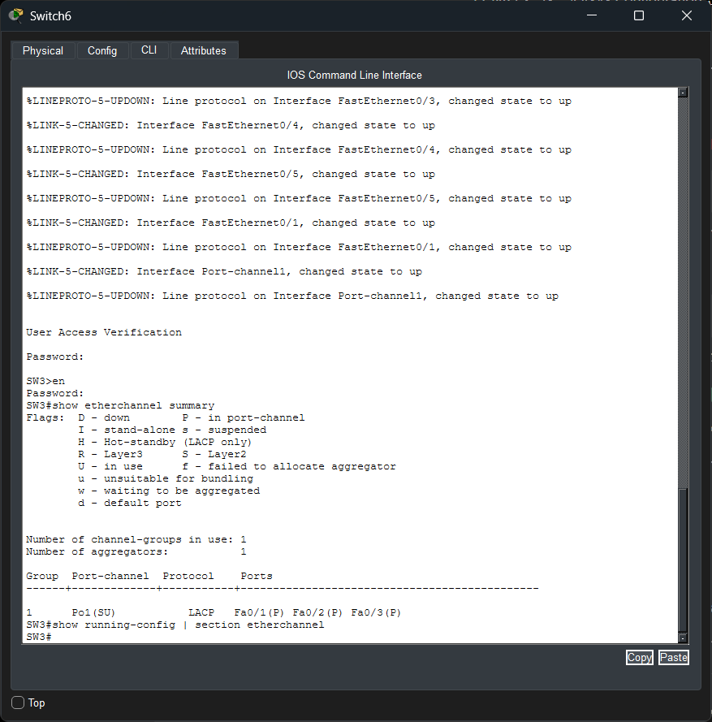
Figure. EtherChannel verification on Switch6.
Methodology: EtherChannel was configured using LACP to combine multiple physical links into one logical Port-Channel. The verification output shows Port-channel 1 (Po1) operating with LACP and Fa0/1, Fa0/2, and Fa0/3 successfully bundled. This improves link redundancy and provides higher aggregate bandwidth between the switches.

7. OSPF Routing Configuration
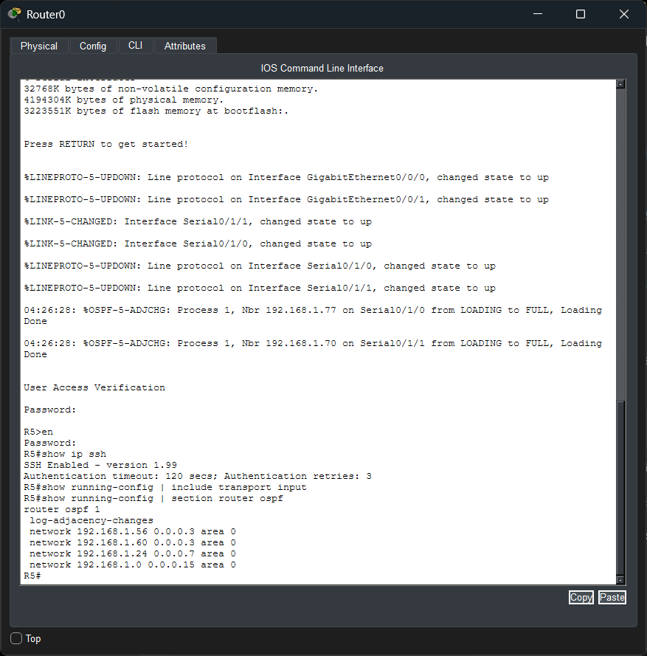
Figure. OSPF configuration on Router0.
Methodology: OSPF process 1 was configured in Area 0. The required LAN and serial networks were advertised using wildcard masks. OSPF allows the routers to dynamically learn routes to remote networks and maintain connectivity across the topology. The earlier interface verification also showed OSPF neighbors reaching the FULL state.

8. Testing and Verification
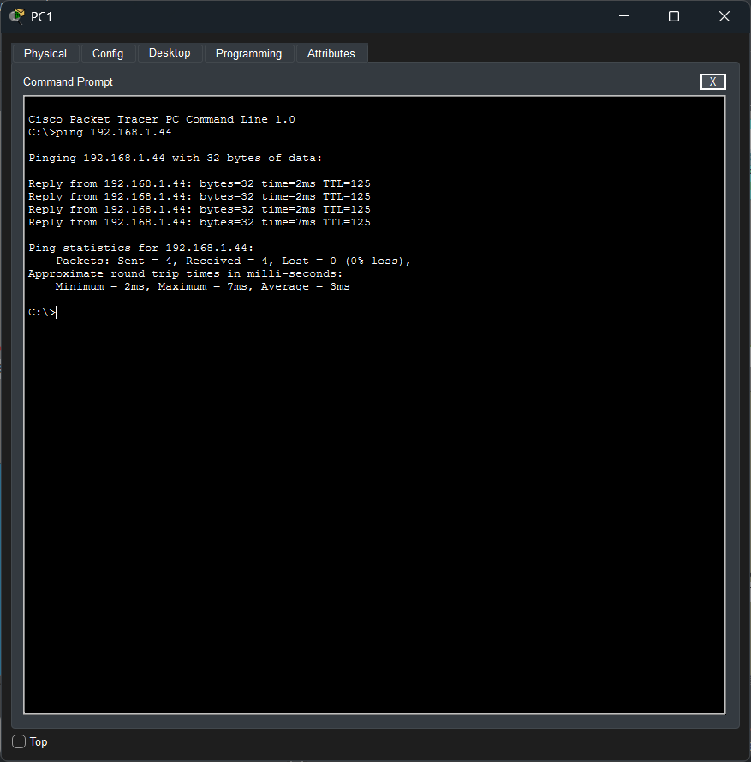
Figure. End-to-end connectivity test from PC1 to PC9.
Methodology: Connectivity was verified by sending four ICMP echo requests from PC1 (192.168.1.3) to PC9 (192.168.1.44). All four packets were received successfully, resulting in 0% packet loss. This confirms successful end-to-end communication across multiple routed networks.

Verification Result: 4 packets sent, 4 received, 0% packet loss. The network is operating successfully.

9. Conclusion
The CCNA network project was successfully designed and configured in Cisco Packet Tracer. VLSM was used to divide the 192.168.1.0/24 address space into efficient LAN and point-to-point subnets. Router interfaces and IP addressing were configured according to the addressing plan. OSPF was implemented for dynamic routing, SSH was enabled for secure device management, and LACP EtherChannel was configured to provide link aggregation and redundancy. End-to-end connectivity was verified successfully with 0% packet loss.

